Ex01:

We create new pc with this code:

Sudo kathara vstart –hosthome –eth 0:A –n pc1

Sudo kathara vstart –hosthome –eth 0:A –n pc2

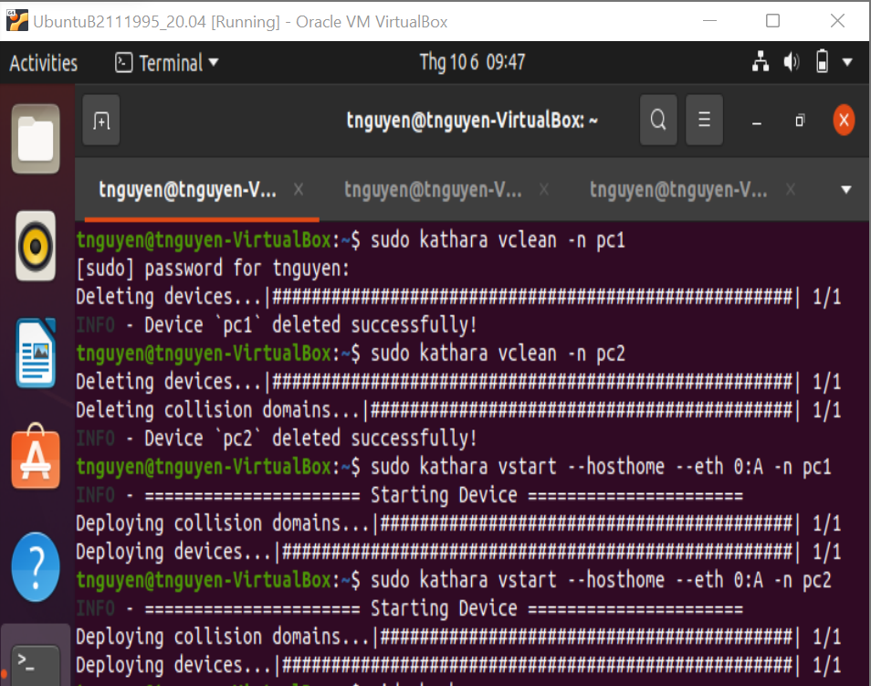

PC1:

Write ifconfig same the slide

After that:

Ping 10.0.0.2

Ctrl + C ( to stop packet)

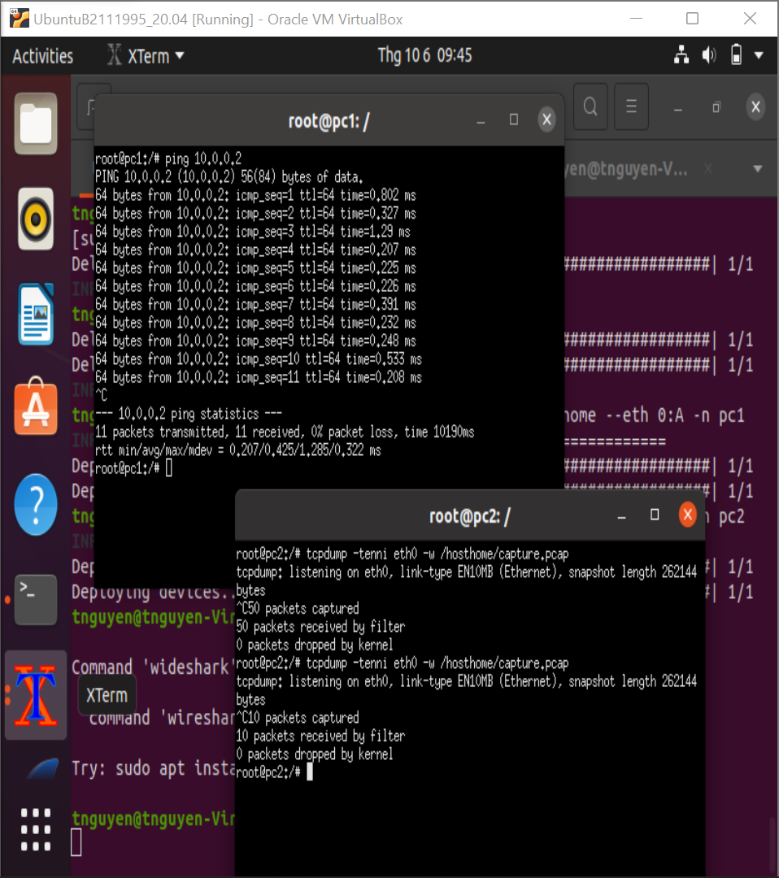

PC2:

Tcpdump –tenni eth0

Ctrl + C

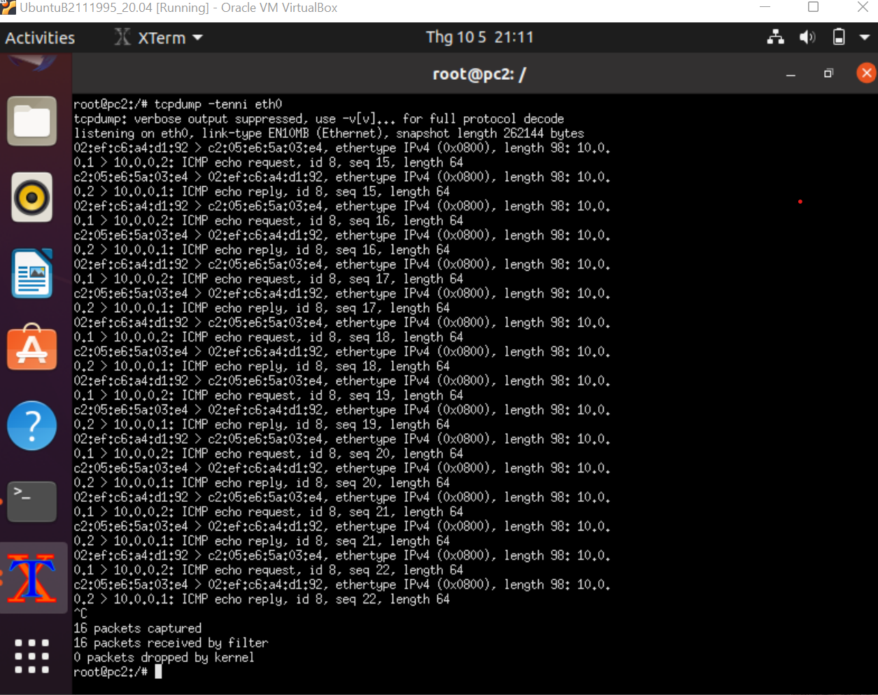

To save in hosthome, we continue to ping from PC1 and using: tcpdump –tenni eth0 –w /hosthome/capture.pcap

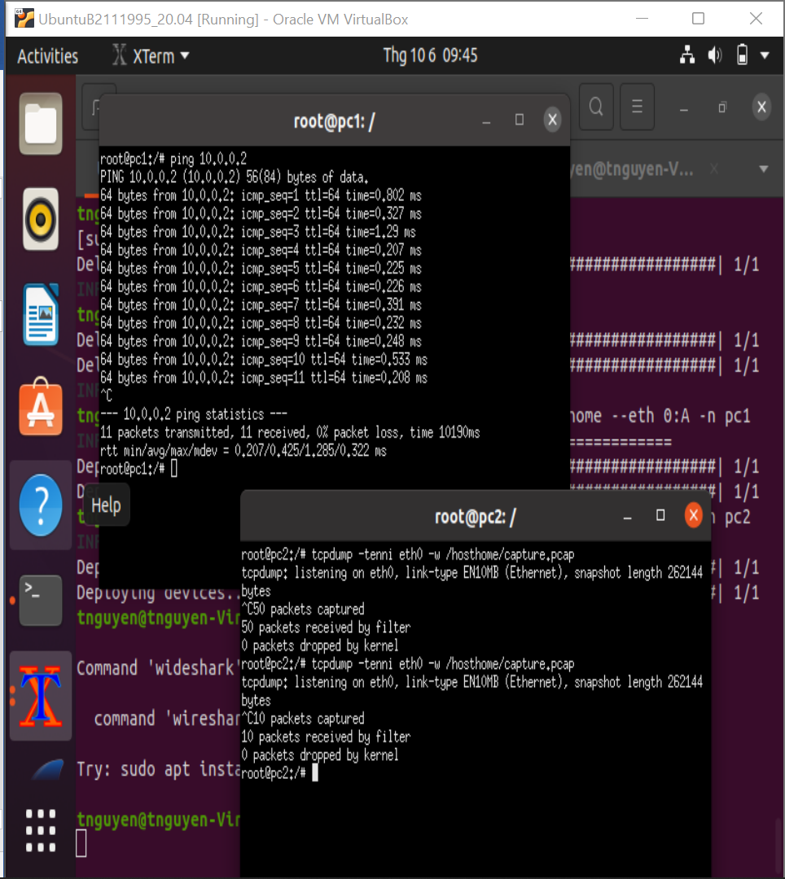

Open Wireshark and open the capture.pcap file:

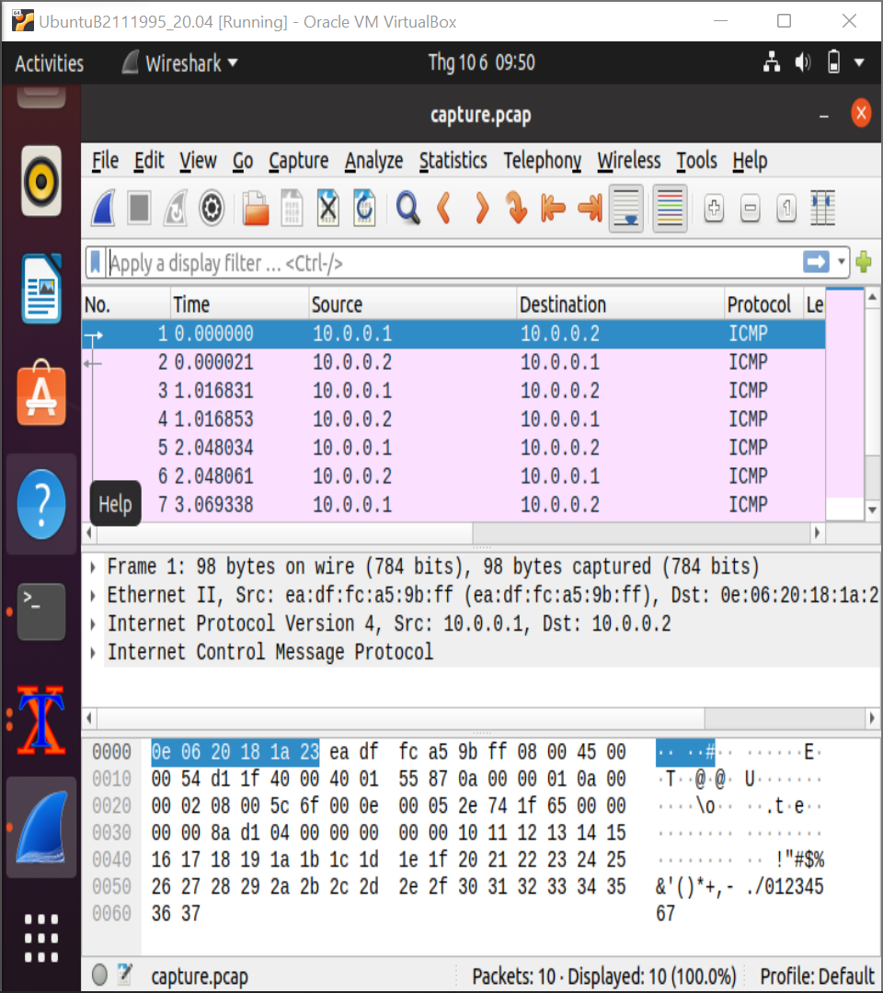

Ex02:

Using mkdir to create new directory ( exercise02)

Cd /home

Mkdir exercise02

Cd exercise02

Mkdir pc{1..4} ( To create a directory)

Touch lab.conf ( To create a file )

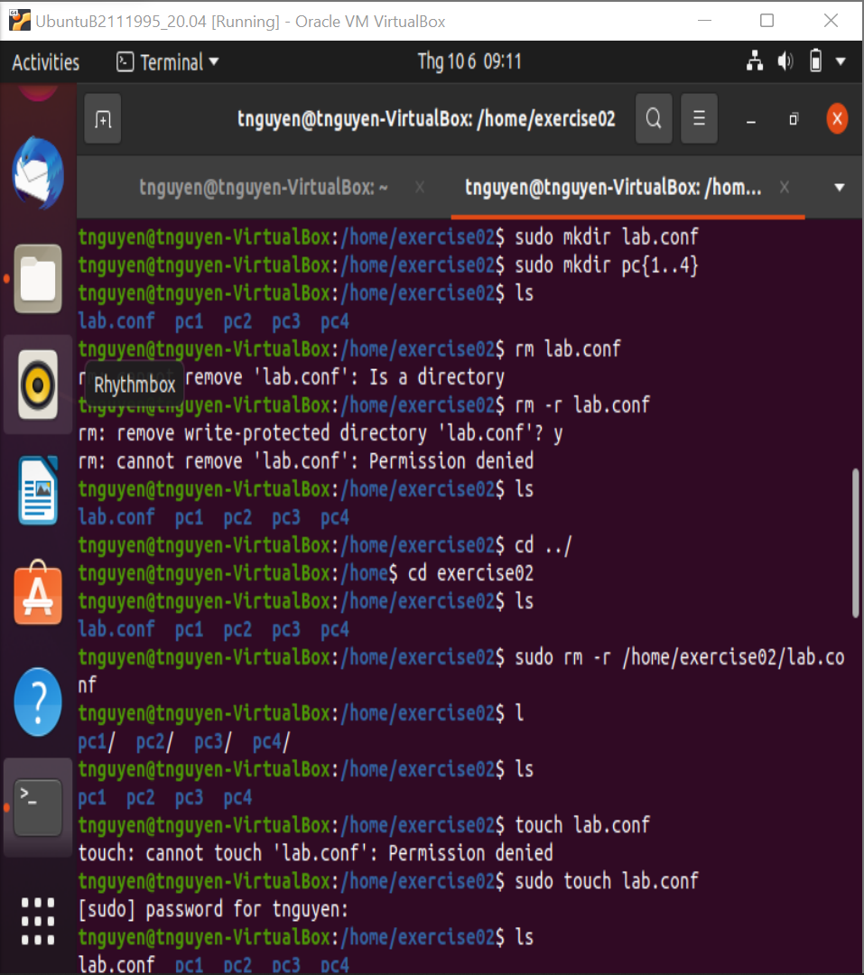

After that install tree packet:

Sudo apt install tree

Using “tree” in exercise02

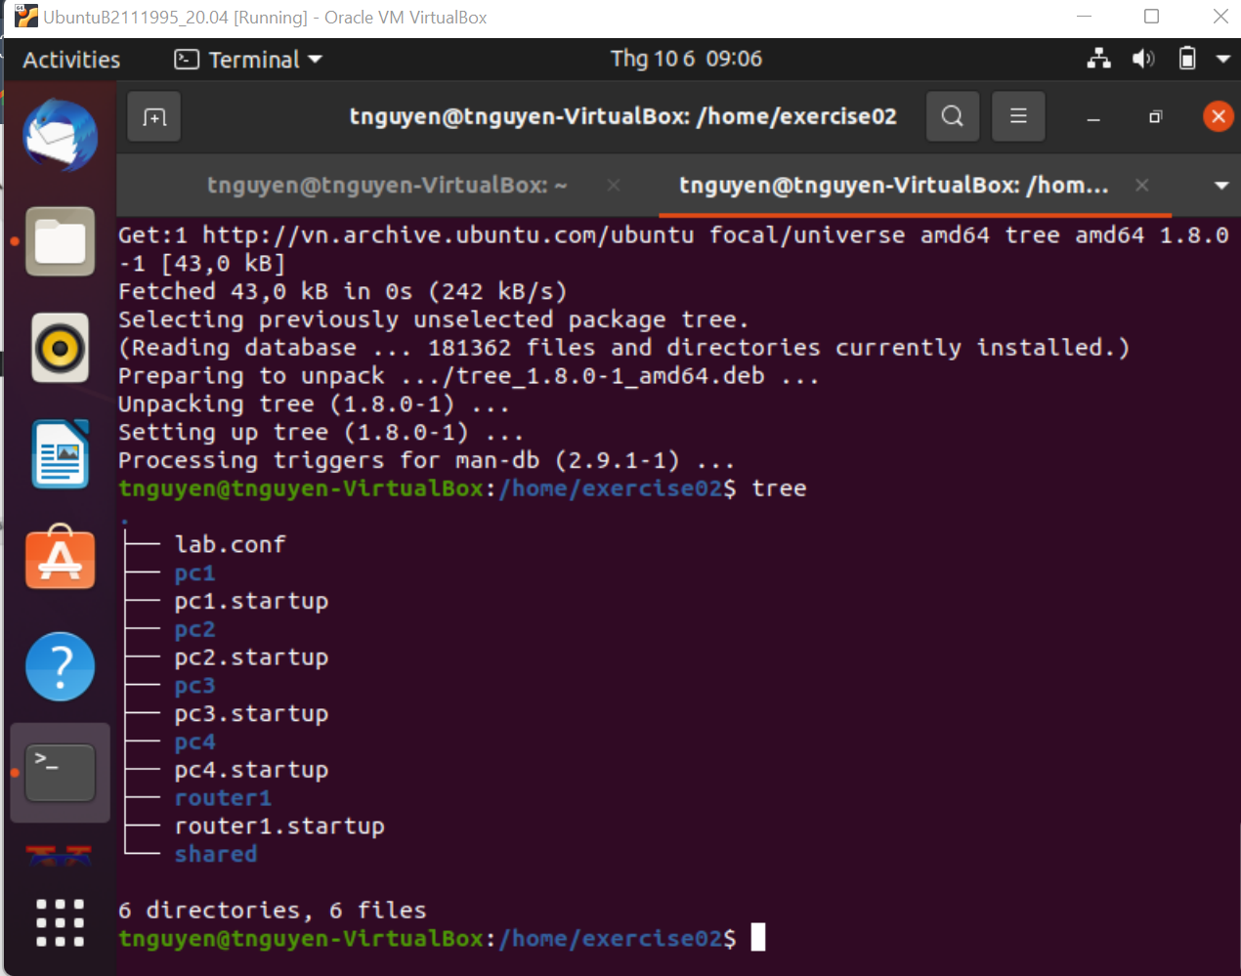

Using gedit with lab.conf

Gedit lab.conf

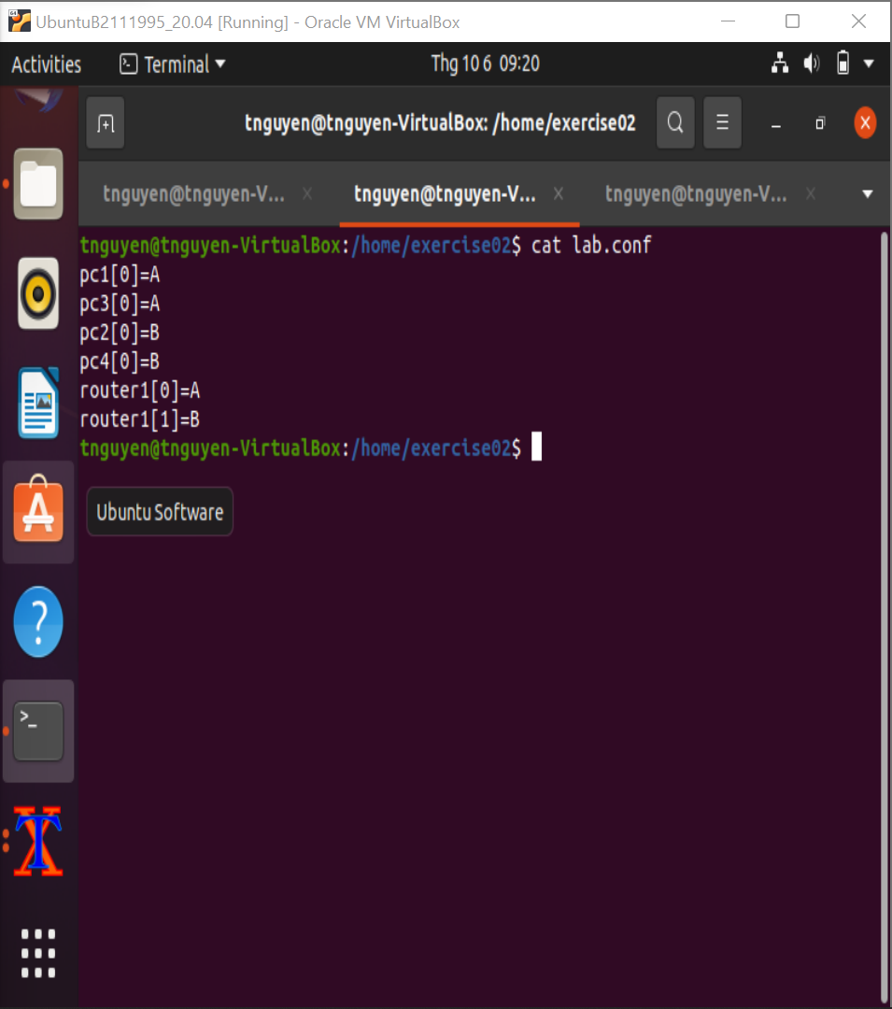

Using Gedit to each file and write same to the slide:

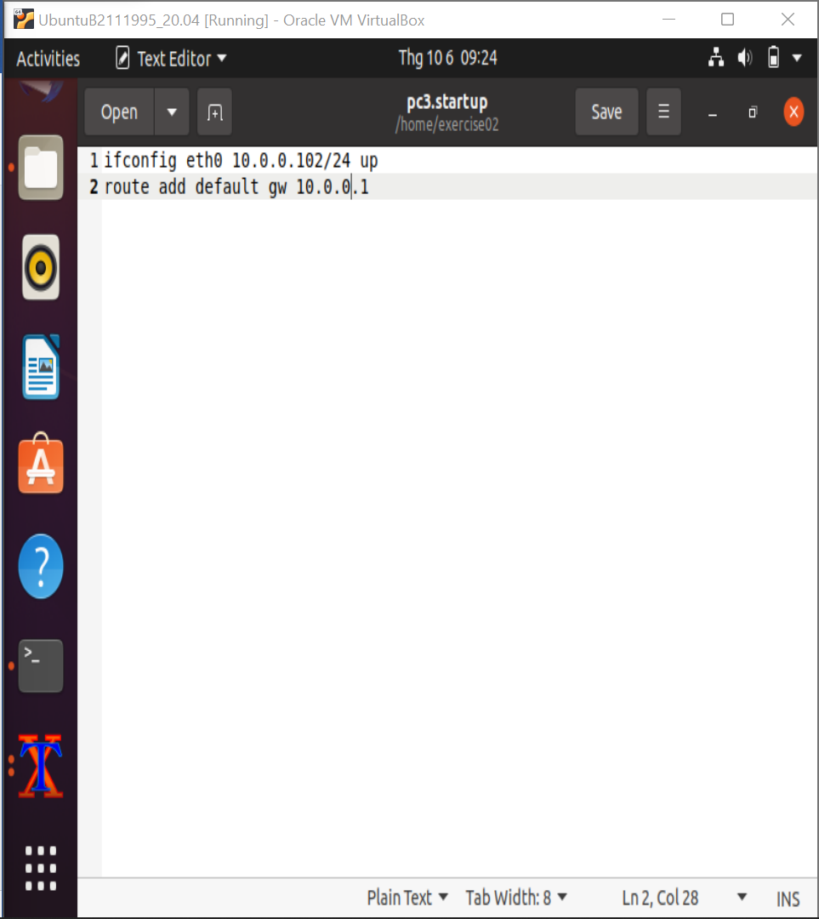

Using cat for display all thing I just do

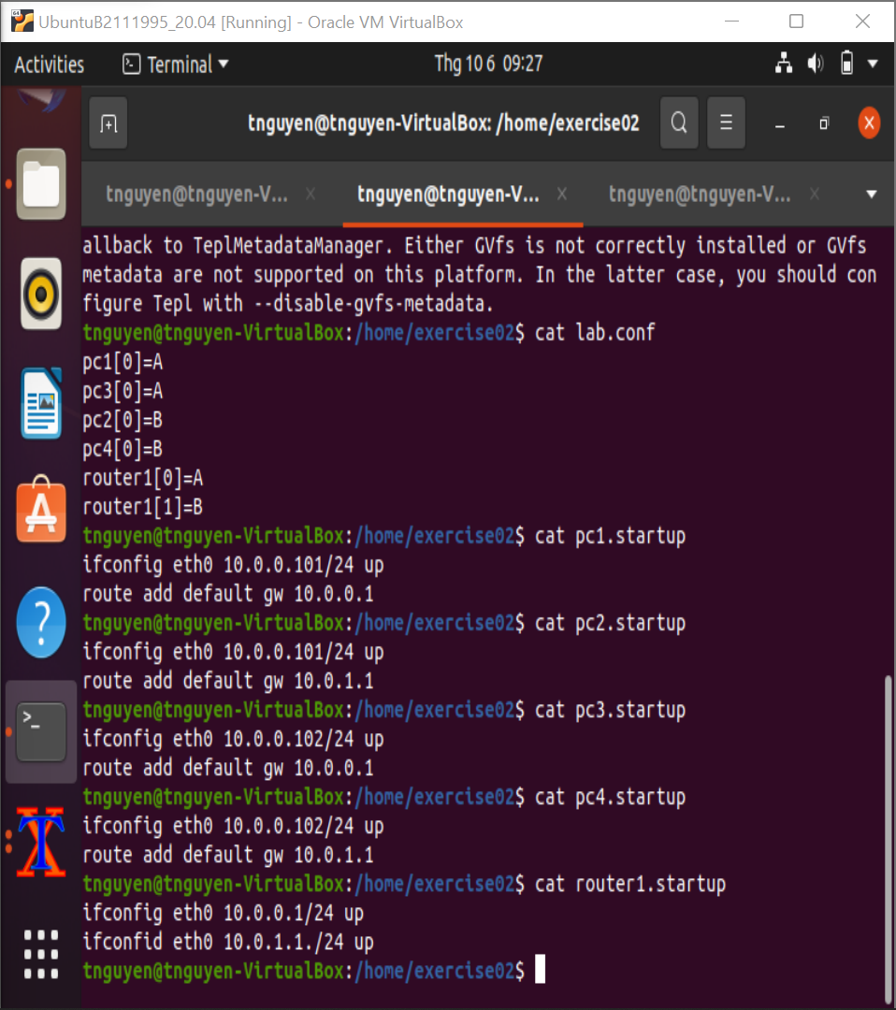

Kathara lstart

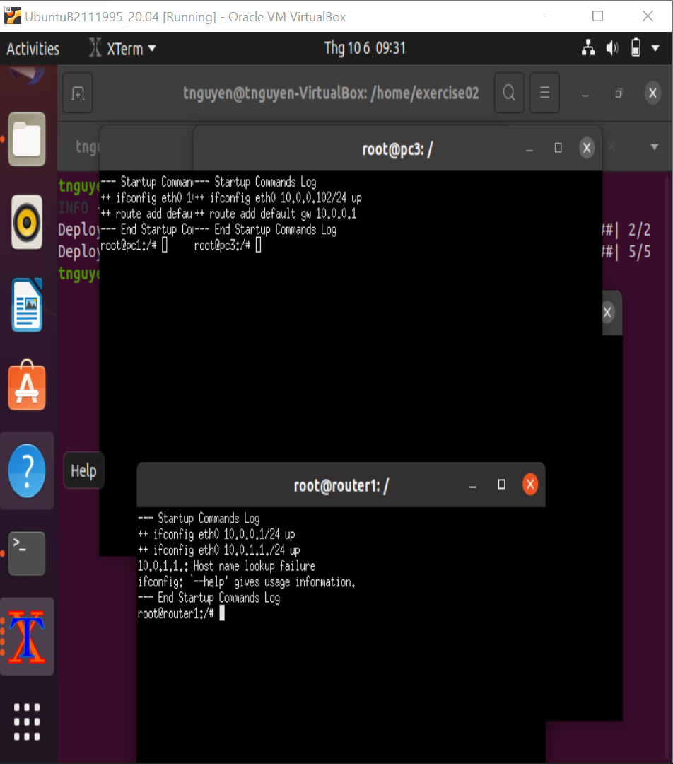

EX03:

Gedit each file like Ex02

After that using cat to display what I just do:

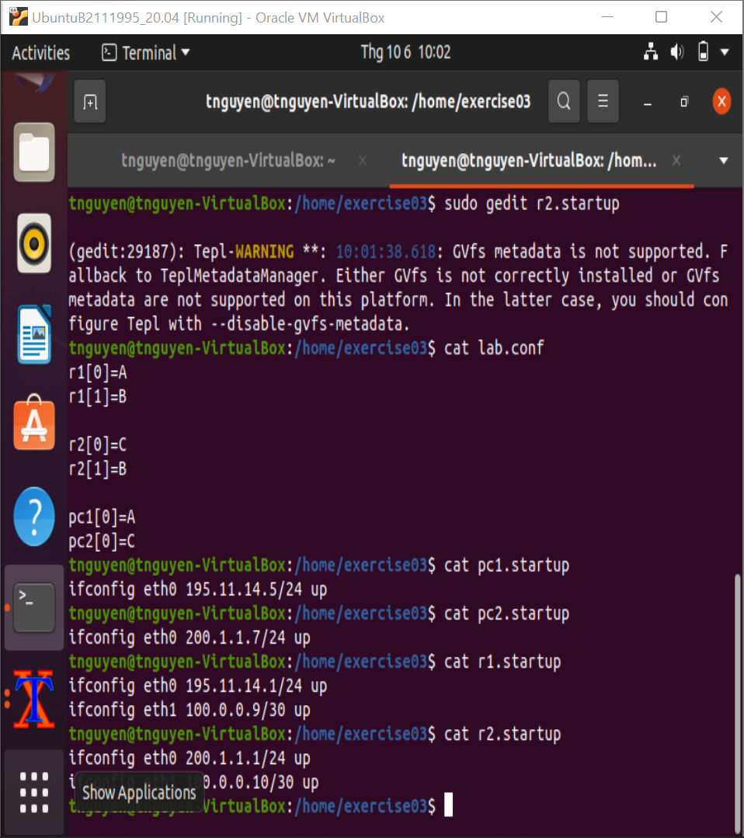

Turn on kathara with: sudo kathara lstart

TESTING CONNECT WITH eth1:

Ping 100.0.0.9

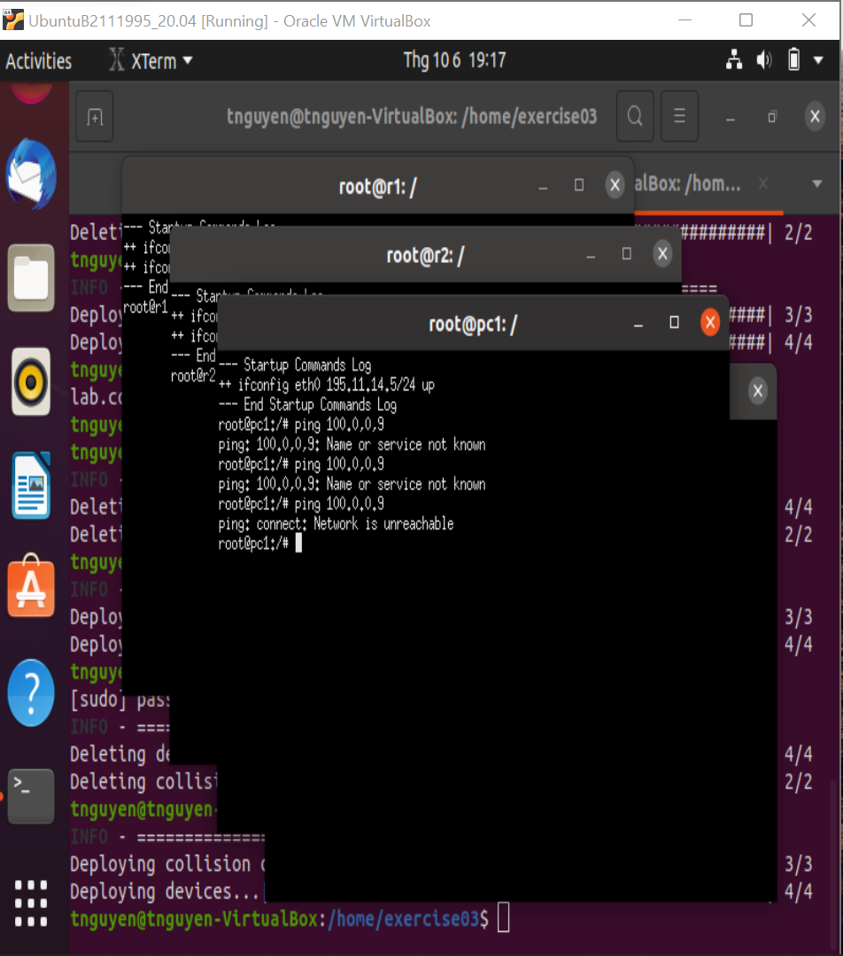

To fix this we need to create a connect between PC1 and eth1 by:

Route add default gw 195.11.14.1

And now we can ping from PC1 to eth1:

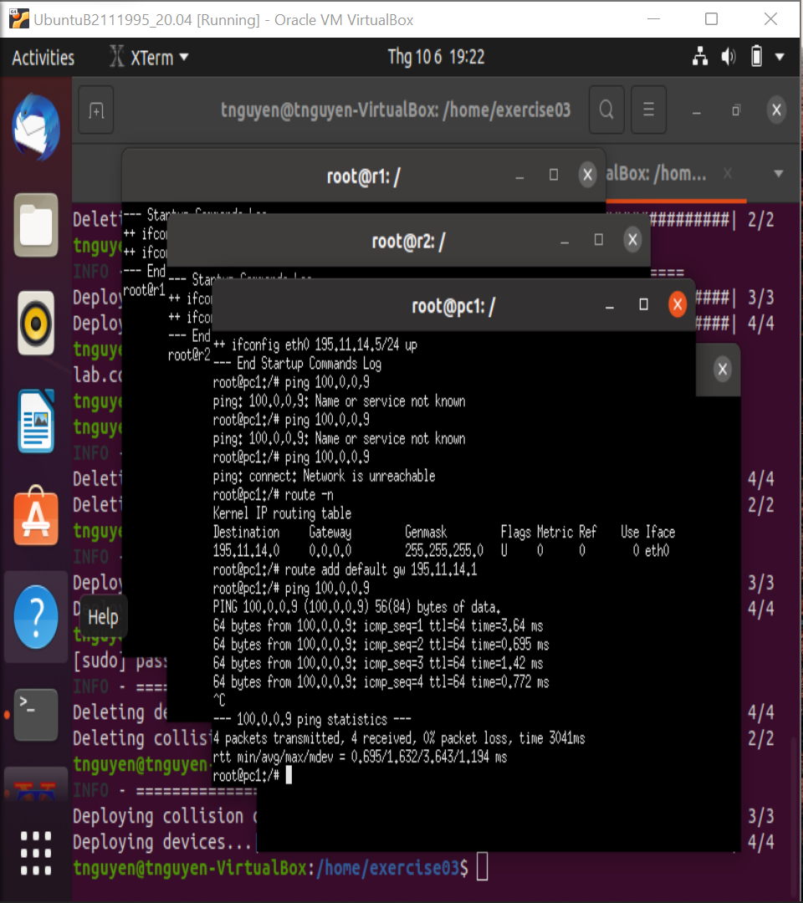

To display the packet is send between PC1 and Route 2 we need to config connect from Route 2 and PC1

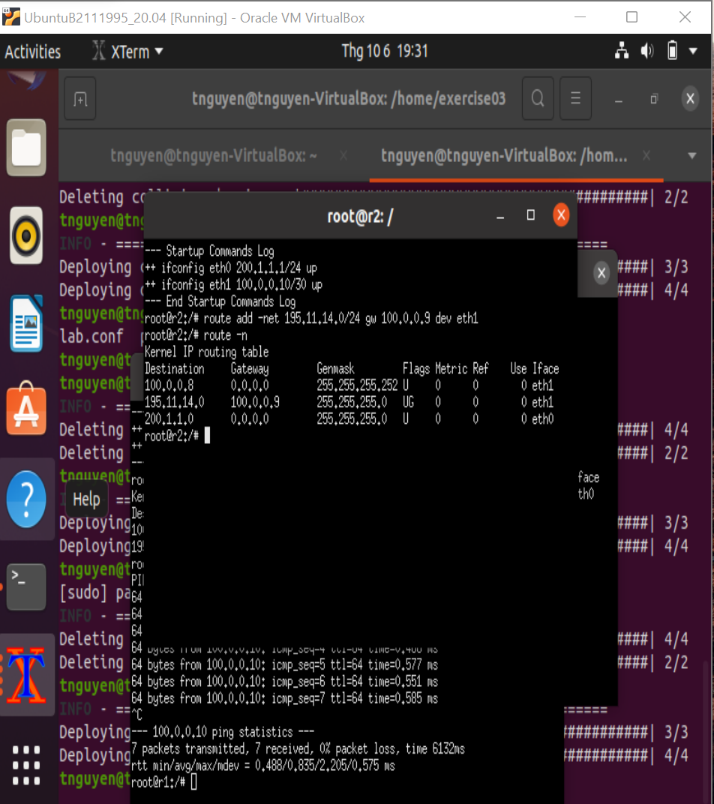

Now we can ping from PC1 to Route2

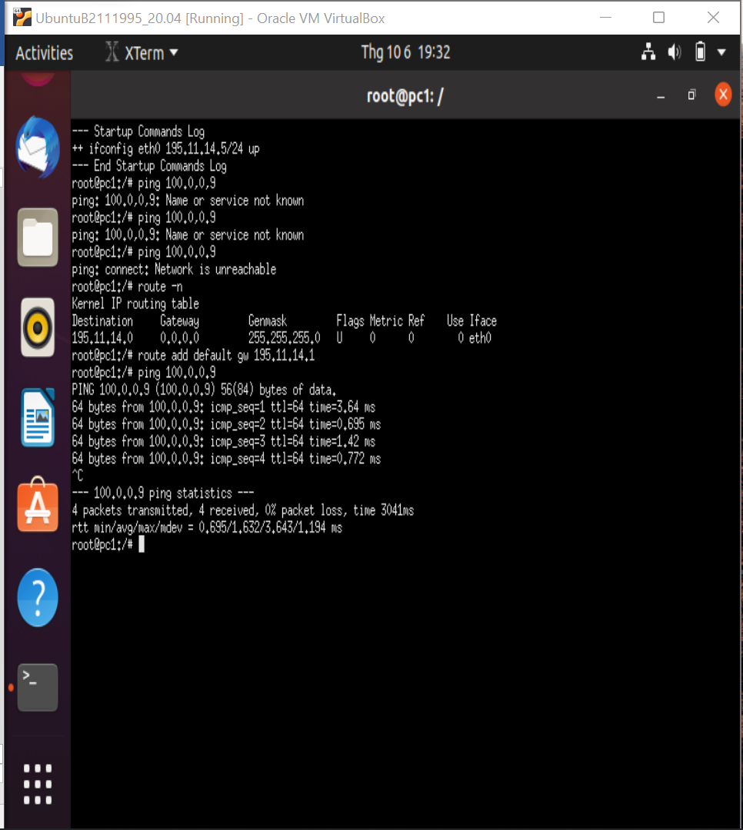

All connect but we can’t ping from PC1 to PC2 because this error:

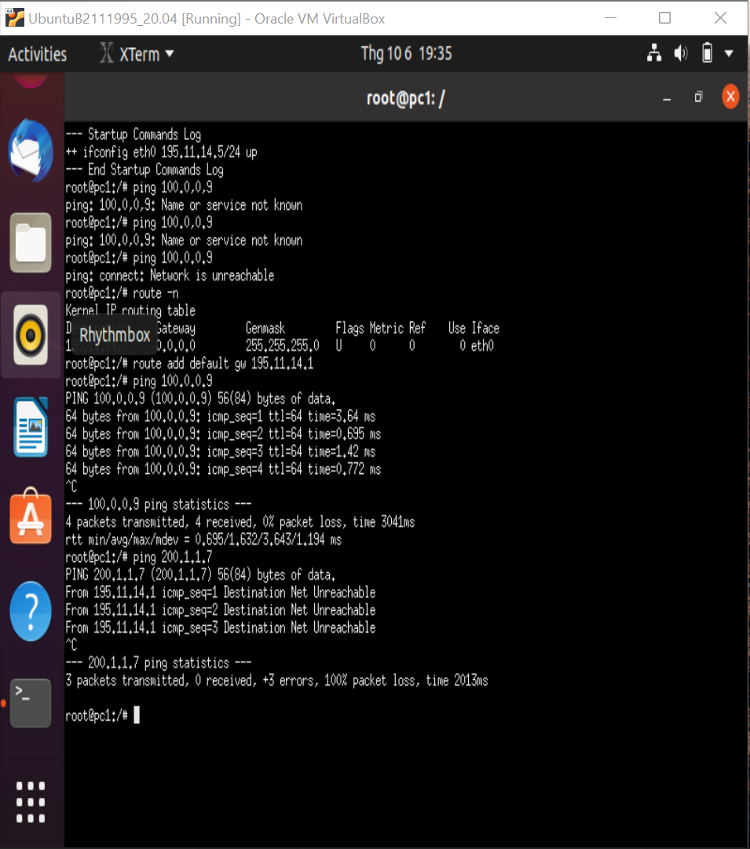

FIX:

We can see PC1 only connect with interface eth0

So we need to PC1 connect with interface eth0 of PC2 by:

Route add –net 200.1.1.0/24 gw 195.11.14.1 dev eth0

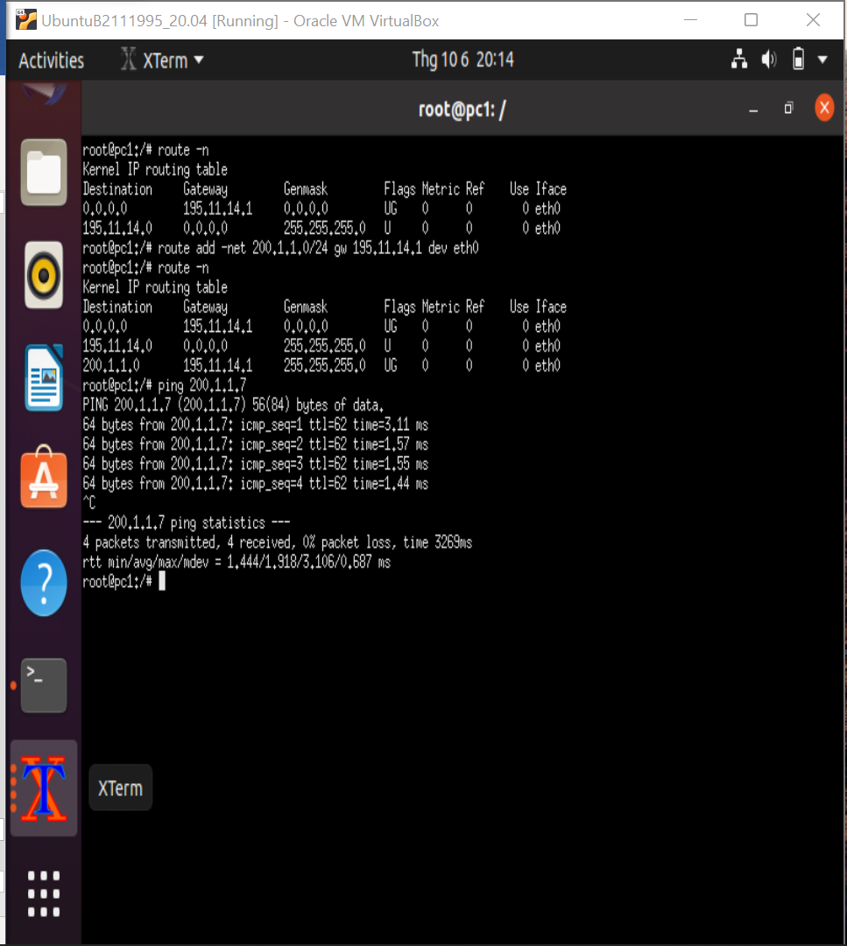

Then we need to connect a line between PC2 to PC1 by:

Route add –net 100.0.0.8/30 gw 200.1.1.1 dev eth0 ( line connect PC2 and eth1)

Route add –net 195.11.14.0/24 gw 200.1.1.1 dev eth0

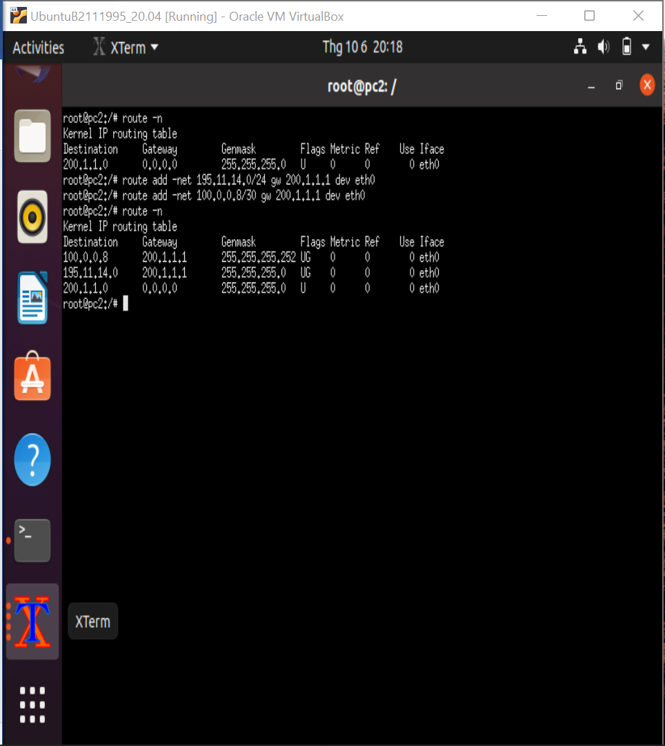

Now we can ping from PC1 to PC2 without error:

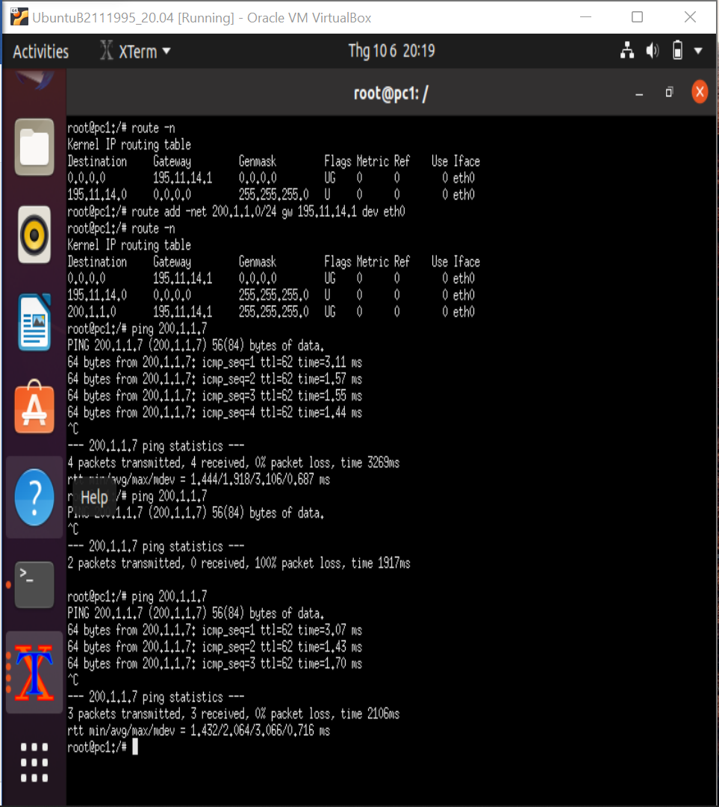

Or ping from PC2 to PC1:

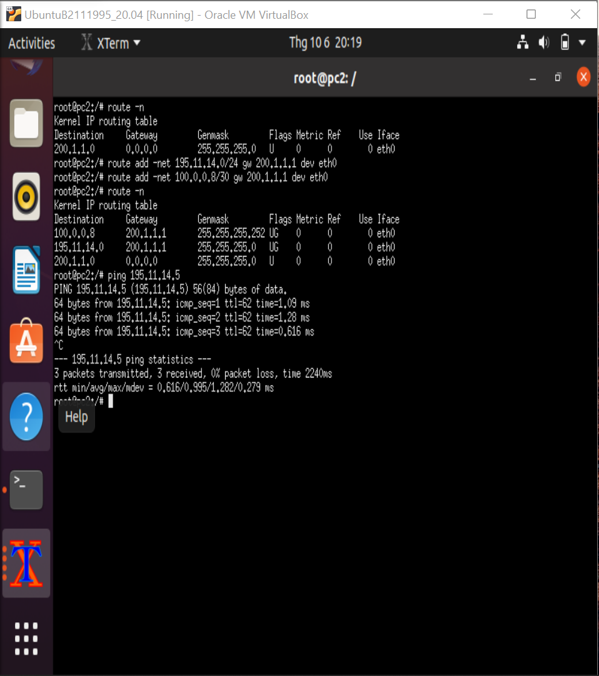

EX04:

Configuration:

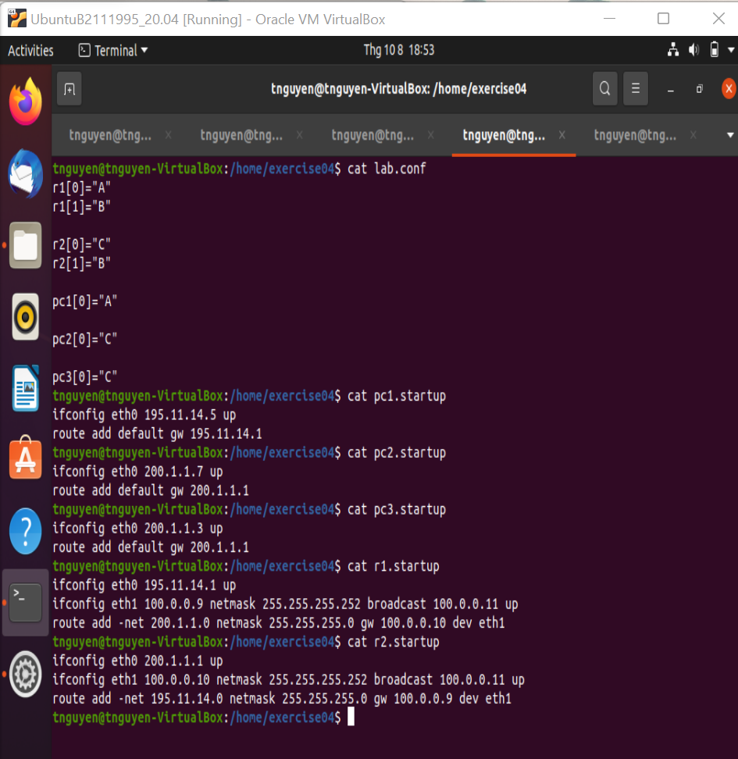

Using arp to configure network mapping:

PC3: Ping 200.1.1.7

Arp –n

PC2:

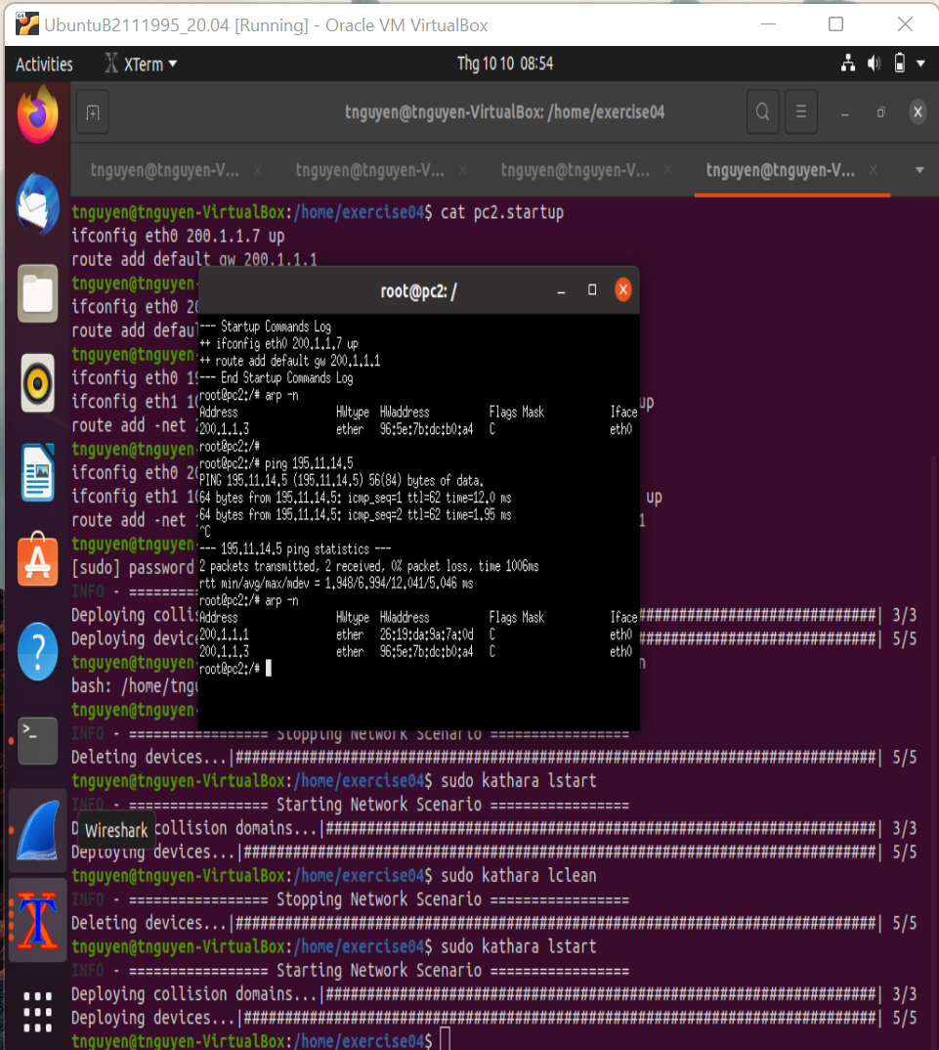

R1:

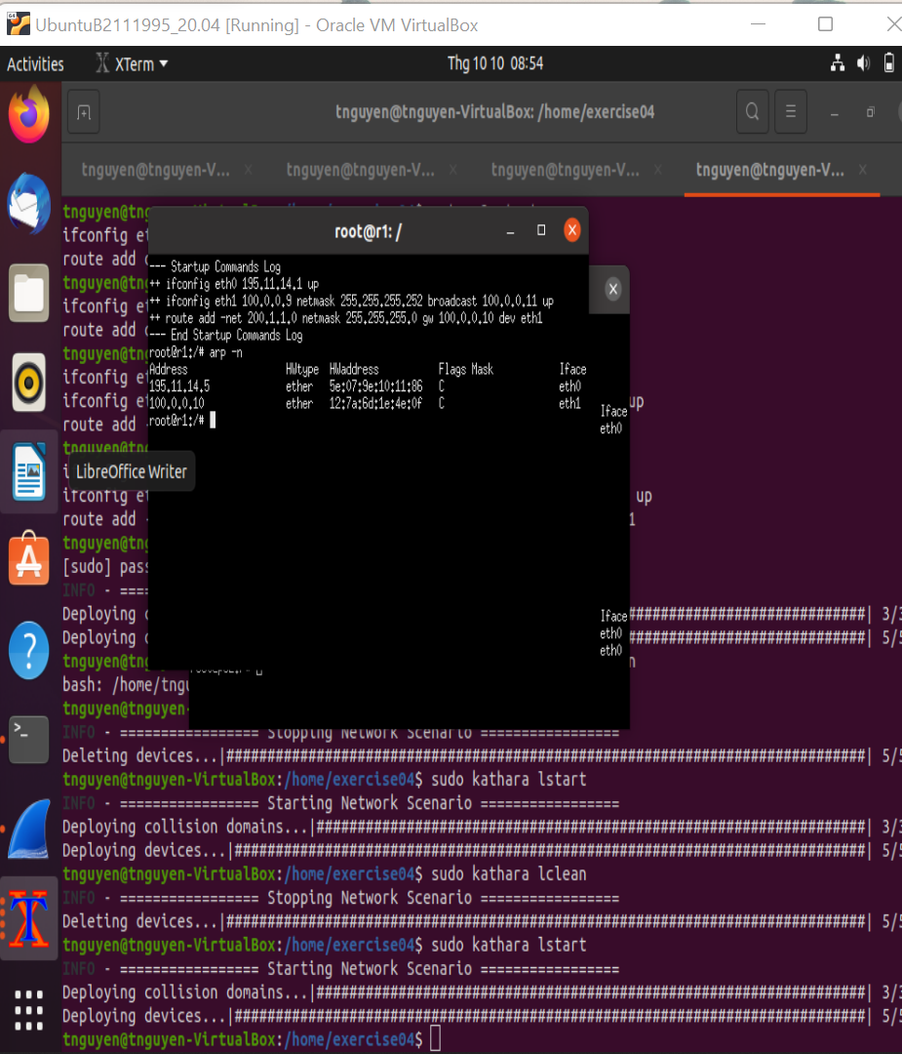

R2:

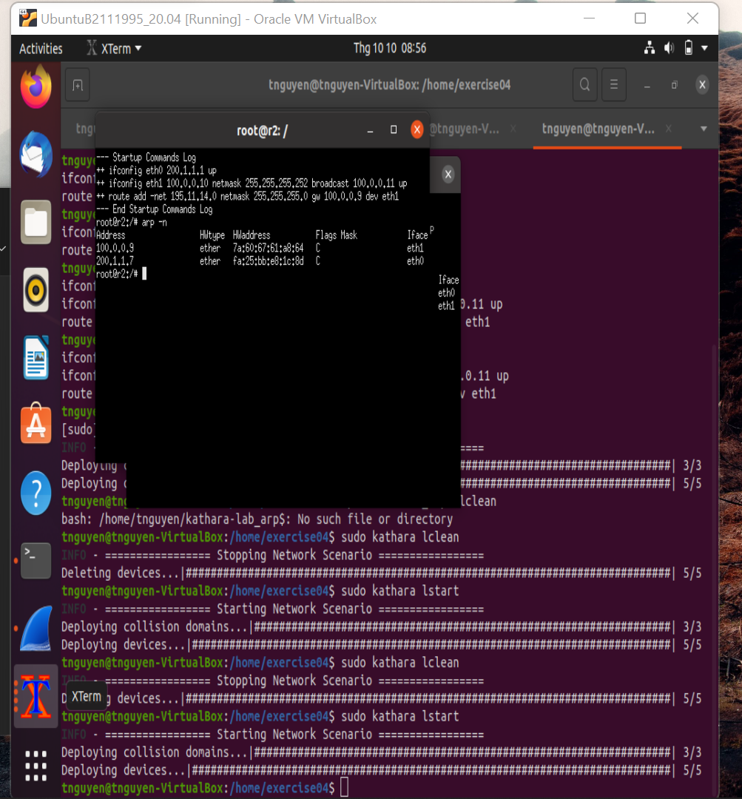

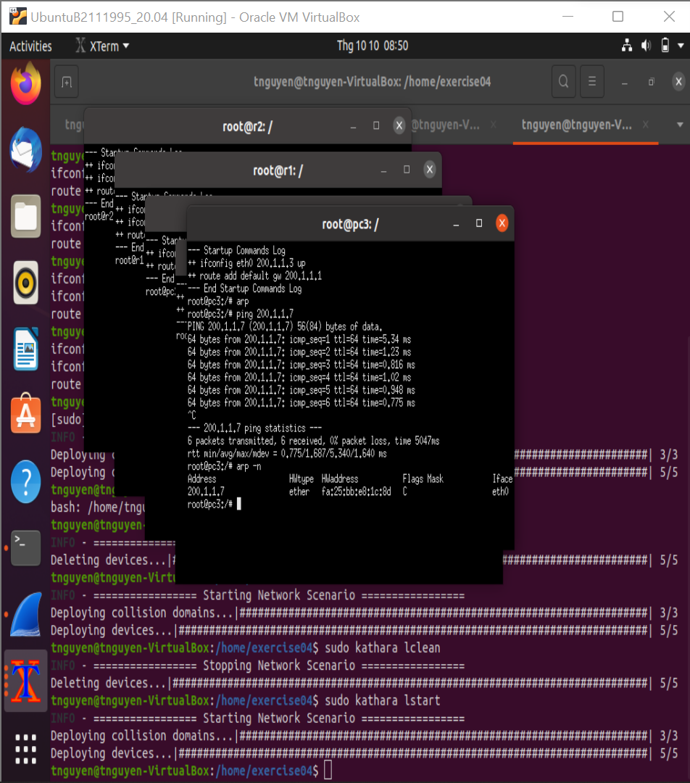

\*PROPOSED EXERCISE 1:

\*These packets:

+ ARP packets: ARP Request and ARP Reply

+ ICMP Echo Request and Reply

+ Ethernet Frames

+ Ethernet Broadcast

For example when I ping from PC2(200.1.1.7) to PC1(195.11.14.5) and I use tcpdump –tenni eth1 on Router we have:

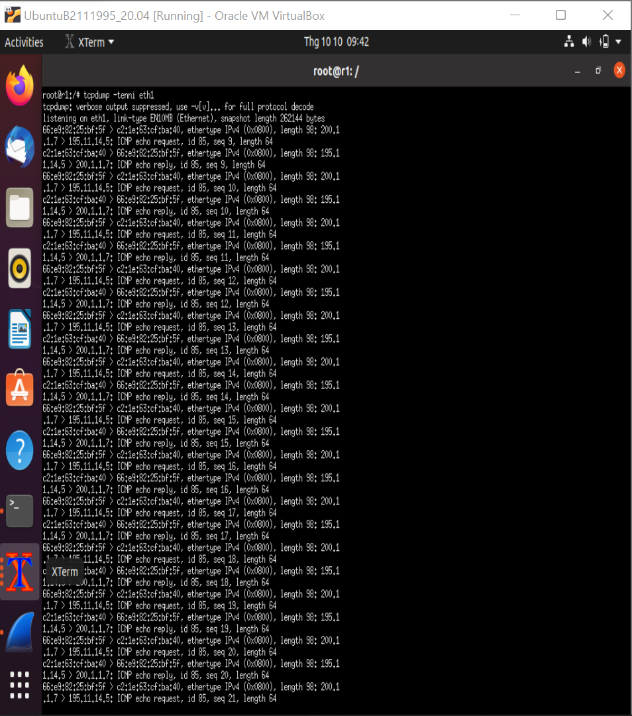

\*PROPOSED EXERCISE 2:

When I choose ping an unreachable destination

* In case 1: local destination ( only R2 run tcpdump )

These packets are exchanged:

+ Ethernet Broadcast

+ ARP packets: only ARP request

+ ICMP : packets not exist.

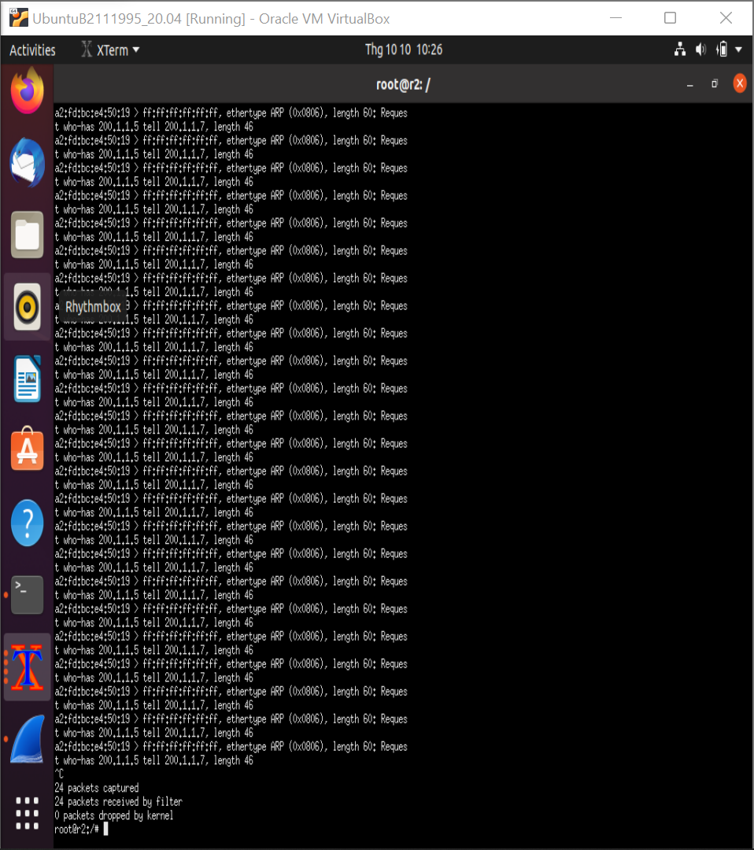

* In case 2: non local destination:

These packets are exchanged:

+ ARP packets: it has only ARP request

+ ICMP packets: only has a ICMP echo request

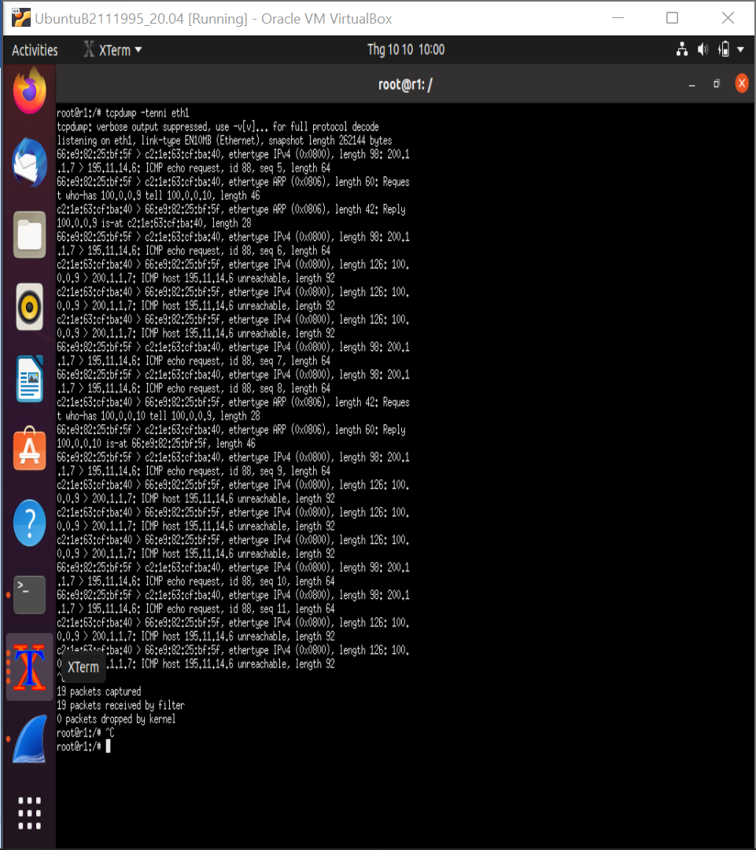

EX05:

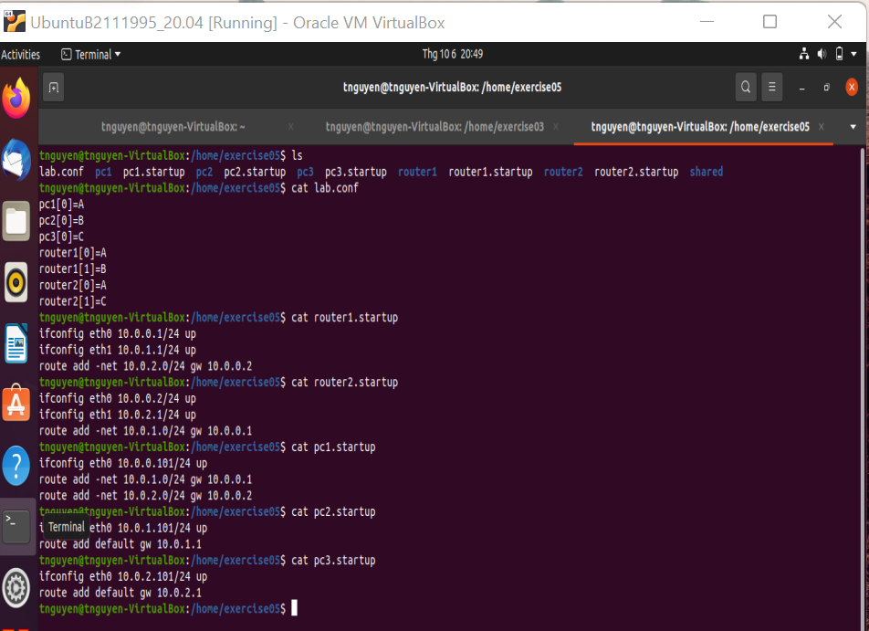

SIZE OF FRAME: 98 bytes

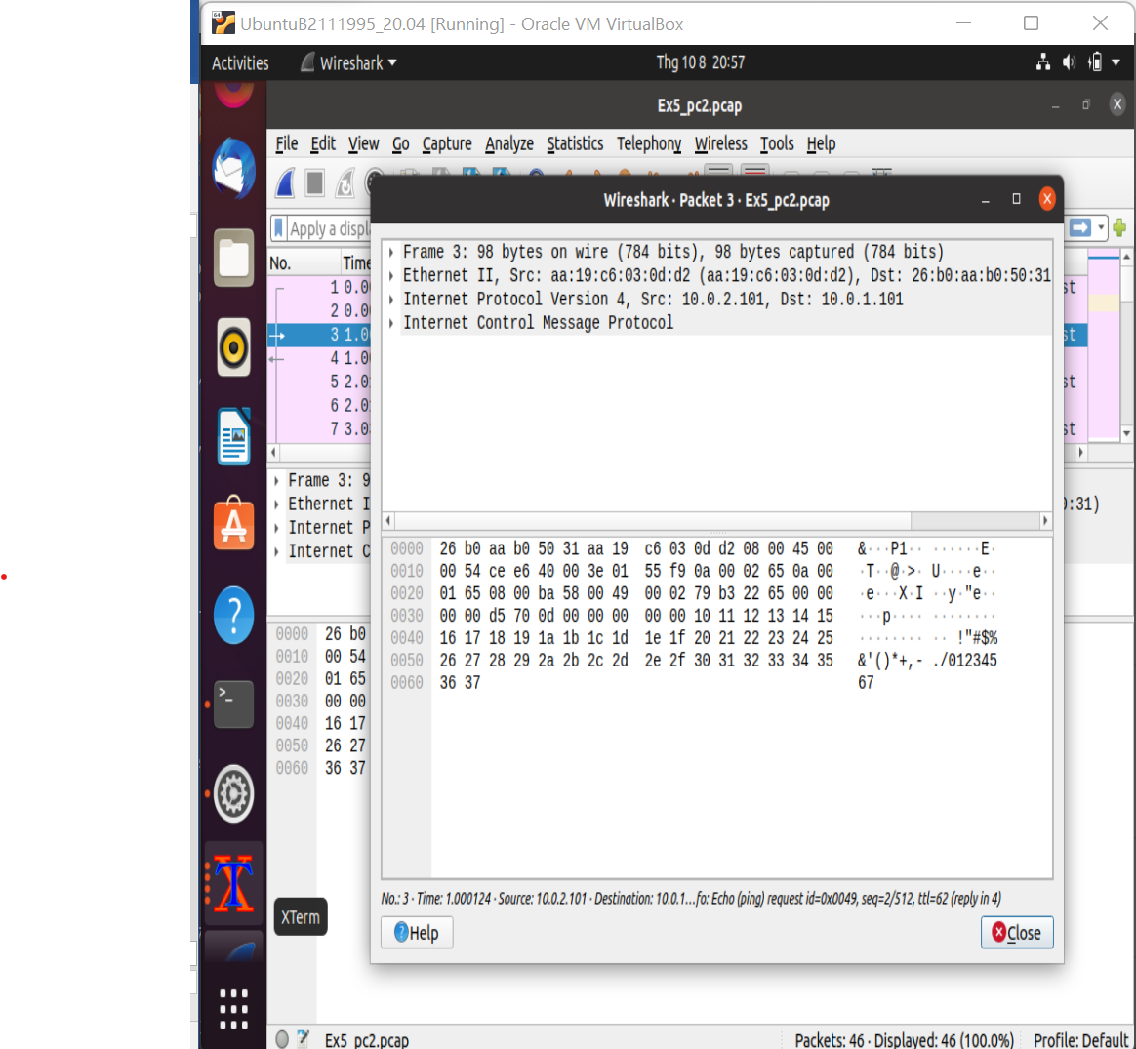

PROTOCOL: ICMP

Which layer: 3 ( Network layer)

48 bytes for the message content

Source: 10.0.2.101

Destination: 10.0.1.101

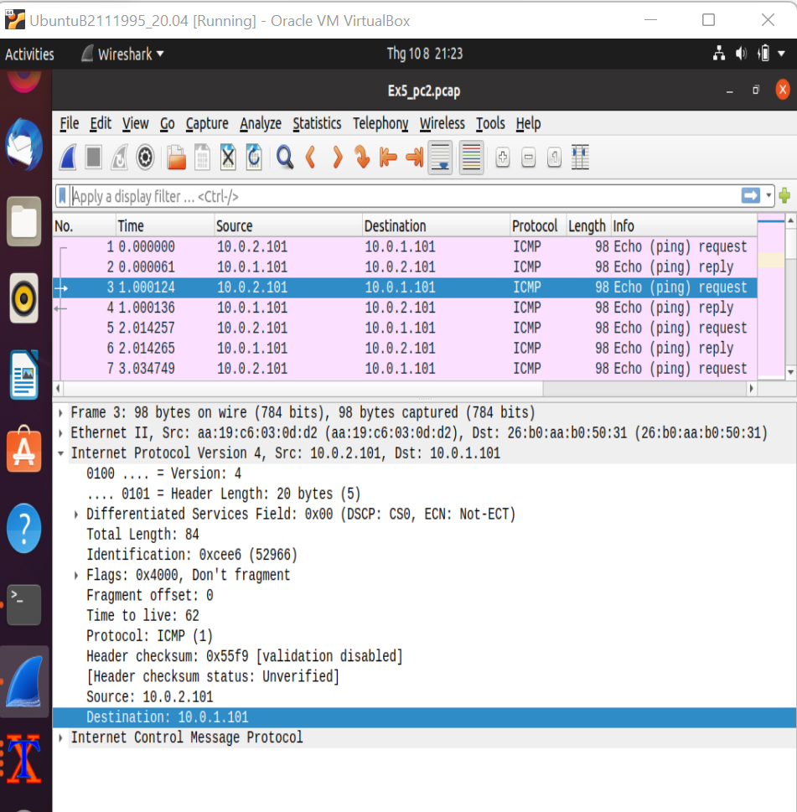

Length of IP packet header: 20 bytes

Fields that Header include:

+ Different Services Field: 0x00

++DSCP : CS0 : 1 bytes

++ ECN : Not –ECT ): 1 byte

+ Total length: 84 ( 2 bytes )

+ Identification: 0xcee6 ( 2 bytes )

+ Flags: 0x4000, Don’t fragment ( 2 bytes )

+ Fragment offset: 0 ( 2 bytes)

+ Time to live: 62 ( 1 byte)

Total length : 84 ( 2 bytes)

\*MAC Address:

+ Destination: 26:b0:aa:b0:50:31

+Source: aa:19:c6:03:0d:d2

\*Type value: 0x0800 (IPv4)